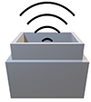

www.connectedlittleboxes.com

# Getting started with a Connected Little Box using WiFi

Welcome to your Connected Little Box. If you want your box to be connected you will have to enter the settings for the Wi-Fi network you want it to use and configure the MQTT connection that the box will use to connect with other boxes and services. These settings are all stored in the box automatically.

The easiest way to configure your box is to use the connect to it with your phone or computer over Wi-Fi and then enter the setting values via your browser. When a brand-new box starts it creates a WiFi access point called **CLB**. You can connect to this using your phone, tablet or laptop and browse to the settings page at **http://192.168.4.1** to put the box on your WiFi so that you can control it remotely. If you have a light you can tell with it is in access point mode because all the lights will be pale grey.

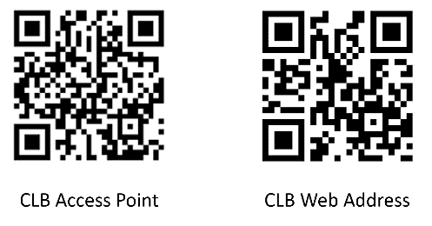You can also use these QR codes to connect to the device for configuration. Scan them with your phone and there is a good chance your phone will prompt you to connect.

Use the left hand QR code first to connect to the CLB access point and the right hand one to open the configuration web page.

This is the configuration web page. It might look slightly different on your device.

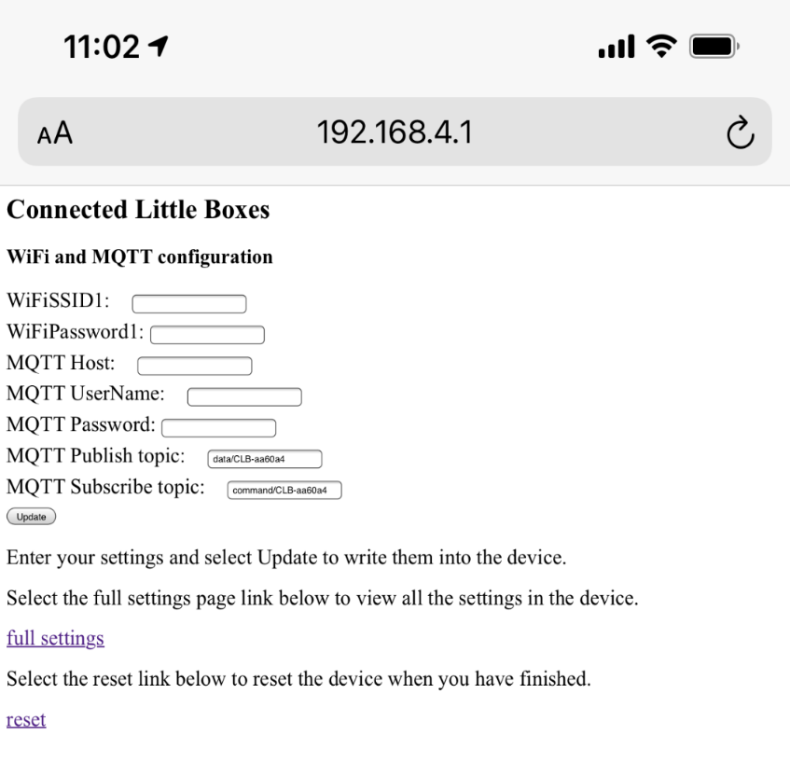Enter your WiFi access point SSID and password. If you have an MQTT host that you want to use, enter those details too. For testing you can use the open MQTT host at hivemq so enter the following into the MQTT host field and leave the others blank.

broker.hivemq.com

Make a note of the MQTT publish and MQTT subscribe topics on this page. These are the addresses on MQTT of the box and you will use them to interact with it. You can leave them at the default topic names or you can change them.

Once you have entered all your setting values click the **Update** button to store the settings. Then click the **reset** link. The device will reset and connect to your network. If you have connected to the hivemq broker you can use the HiveMQ web app to send commands to the device

If you want to change the configuration of the box you can click the **Full Settings** link to open up a menu page for all the setting values.

If you get your WiFi settings wrong the box will try to connect for a while when it is switched on and then return to the Access Point mode so that you can connect to it and sort out the settings.

Don't worry about the red and green flashing lights as a box starts up. It is supposed to do that.